Full Stack Development With MERN ( AI&ML )
………….............................................................................

INTRODUCTION
----------------------------
Project Title: Weather-Based Prediction Of Wind Turbine Energy Output:
A Next-Generation Approach To Renewable Energy Management

TEAM ID: LTVIP2026TMIDS67435

Team Members:
          - Chamarthy Venkata Swathi
          - Chegondi Pavani
          - Chilakapati Geethanjali
          - Chinthalapudi Sucharitha

Project Overview
------------------------
Purpose: The main purpose of the Weather-Based Prediction for Wintertime Energy system is to:
- Predict energy demand and generation during winter season.
- Analyze weather parameters like temperature, wind speed, snowfall, humidity, and solar radiation.
- Help power companies manage energy supply efficiently.
- Prevent power shortages during extreme winter conditions.
- Support renewable energy optimization (wind, solar, hydro).

Features:
Weather Data Integration
- Collects real-time and historical weather data.
- Uses temperature, wind speed, humidity, and snowfall data.
🔹 Energy Demand Prediction
- Predicts increased electricity demand during cold weather.
- Forecasts heating energy requirements.
🔹 Renewable Energy Forecasting
- Estimates wind power generation.
- Predicts solar energy reduction due to snow/cloud cover.
🔹 Machine Learning Model
- Uses regression or time-series models.
- Improves prediction accuracy using past winter data.
🔹 Dashboard & Visualization
- Graphs for temperature vs energy usage.
- Real-time energy demand display.
- Alerts for peak load conditions.
🔹 Alert System
- Sends warnings during extreme cold waves.
- Helps grid operators prepare backup power.

3️⃣ Benefits for Users
👤 Residential Users
- Plan electricity usage efficiently.
- Avoid high bills during peak winter.
- Prepare for extreme cold days.
🏢 Industrial Users
- Schedule heavy machinery usage.
- Avoid peak hour penalties.
- Improve energy cost planning.
🏭 Power Grid Operators
- Maintain grid stability.
- Reduce risk of power outages.
- Plan energy distribution effectively.

Business Impact:
The aim of the Weather-Based Prediction for Wintertime Energy project is to develop a system that accurately predicts energy demand and renewable energy generation during the winter season using weather parameters such as temperature, wind speed, humidity, and snowfall. This helps in efficient energy management, reducing power outages, optimizing renewable energy usage, and supporting decision-making for users and businesses.

💼 Cost Reduction
- Reduces operational losses.
- Optimizes power generation and distribution.
📈 Better Resource Management
- Efficient use of renewable energy.
- Reduced dependency on fossil fuels.
⚡ Improved Grid Reliability
- Prevents overload and blackout situations.
- Enhances system stability during winter storms.
🌱 Environmental Impact
- Promotes green energy usage.
- Reduces carbon emissions.
📊 Data-Driven Decision Making
- Helps companies make smart investment decisions.
- Supports future energy infrastructure planning.

Scenario:

1. Sudden Snowstorm Impact
Description: A sudden snowstorm is predicted in the city, which may affect both energy demand and renewable energy generation.
Steps:
- User logs in and navigates to the prediction page.
- Inputs weather data for the day:
  - Temperature: -2°C
  - Wind Speed: 30 km/h
  - Snowfall: 15 cm
  - Humidity: 90%
- Clicks “Predict Energy”.
Expected Result:
- System predicts high electricity demand due to heating needs.
- Renewable energy output decreases (solar generation reduced due to snow coverage).
- Dashboard shows spike in demand and low renewable contribution.
- Alert is generated for grid operators to prepare backup energy.

Scenario 2: Low Wind, Overcast Day
Description: A day with minimal wind and cloudy skies may reduce renewable energy generation.
Steps:
Input weather data:
Temperature: 0°C
Wind Speed: 5 km/h
Snowfall: 2 cm
Humidity: 80%
Click “Predict Energy”.
Expected Result:
System predicts that renewable energy contribution will be low.
Total energy demand slightly above normal due to cold.
Alert indicates need to rely more on non-renewable sources.

Architecture
------------------
The project follows a full-stack MERN-like architecture (MongoDB, Express, React, Node.js) with modular structure and API-driven design.
Project
│
├── client/ # Frontend React app
│ ├── public/ # Static assets (HTML, images, favicon)
│ ├── src/
│ │ ├── components/ # Reusable UI components
│ │ ├── pages/ # Pages: Home, About, SignUp, Login, Dashboard
│ │ ├── services/ # API call functions
│ │ ├── context/ # State management (React Context / Redux)
│ │ ├── App.js # Main app routing
│ │ ├── index.js # Entry point
│ ├── package.json
│ └── .gitignore
│
├── server/ # Backend Node.js/Express API
│ ├── controllers/ # Business logic for endpoints
│ ├── routes/ # API routes
│ ├── models/ # MongoDB schemas
│ ├── middlewares/ # Authentication, error handling, logging
│ ├── utils/ # Helper functions
│ ├── server.js # Express app setup
│ ├── config.js # DB and environment setup
│ ├── package.json
│ └── .gitignore
│
├── README.md # Project instructions
└── .env.example # Environment variables template

Frontend:
Flask templates (HTML, CSS, JavaScript) used for UI design and dashboard visualization.
Backend:
Python Flask application handling API requests, ML model predictions, and weather data integration.
Database:
Local CSV dataset (T1.csv) for training and testing. Model stored as .sav file using Joblib. Future scope includes cloud database integration (MongoDB Atlas/AWS RDS)

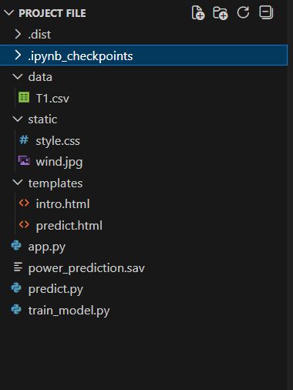

4️⃣ Setup Instructions (AI Version)
Prerequisites
  - Python 3.9+
  - Flask
  - Pandas, NumPy, Scikit-learn, Matplotlib
  - Joblib
  - OpenWeather API key

Installation Steps
- Clone project
- Setup backend
- Setup ML service:
- pip install scikit-learn pandas numpy joblib
- Train model:
- model.fit(X_train, y_train)
- joblib.dump(model, "energy_model.pkl")
- Run the Flask server with python app.py.

. Folder Structure
- Client (Frontend):
  - templates/ → HTML files (intro page, dashboard).
  - static/ → CSS, JS, and images.
- Server (Backend):
  - app.py → Flask application.
  - model_training.py → ML model training script.
  - power_prediction.sav → Saved Random Forest model.
  - data/ → Dataset files.

Running the AI Application
- Start Backend
- Start ML Microservice
- Start Frontend
Open:
http://localhost:3000
Test:
Sign Up → Login → Submit Weather → View AI Prediction

6️⃣ AI Algorithms Used
6.1 Linear Regression (Baseline)
Simple interpretable model.

6.2 Random Forest Regression (Primary)
Handles non-linearity and noise.

6.3 XGBoost (Advanced)
High-performance gradient boosting.

6.4 LSTM (Optional Time-Series)
Predicts next-hour/day energy output.

6.5 Logistic Regression (Alert Model)
Classifies extreme weather risk.

7️⃣ Model Training Strategy
- Train/Test Split (70/15/15)
- K-Fold Cross Validation
- Hyperparameter tuning
- Feature importance ranking

8️⃣ Evaluation Metrics
- MAE
- MSE
- RMSE
- R² Score
Example:
R² = 0.91
RMSE = 450 kWh

9️⃣ Testing Strategy (AI-Focused)
Backend ML Testing
- Test model prediction accuracy
- Validate feature transformation
- Check anomaly detection
Frontend Testing
- Validate dashboard updates
- Confirm graph rendering
- Check alert triggering
E2E Testing
User → Submit → Predict → Store → Display

Screen shots :

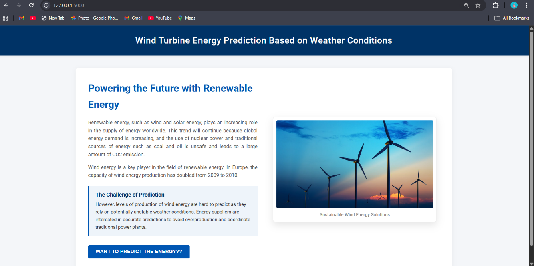 API Documentation
- Endpoint 1: /predict
  - Method: POST
  - Parameters: TheoreticalPower, WindSpeed
  - Response: Predicted Active Power
- Endpoint 2: /weather
  - Method: GET
  - Parameters: City name
  - Response: Weather data (temperature, humidity, pressure, wind speed)

Authentication
- Currently open access.
- API key required for OpenWeather API integration.
- Future scope: JWT-based authentication for secure access.

9. User Interface
- Intro page with project overview.
- Dashboard with:
  - Weather data display.
  - Prediction module.
  - Visualization graphs.

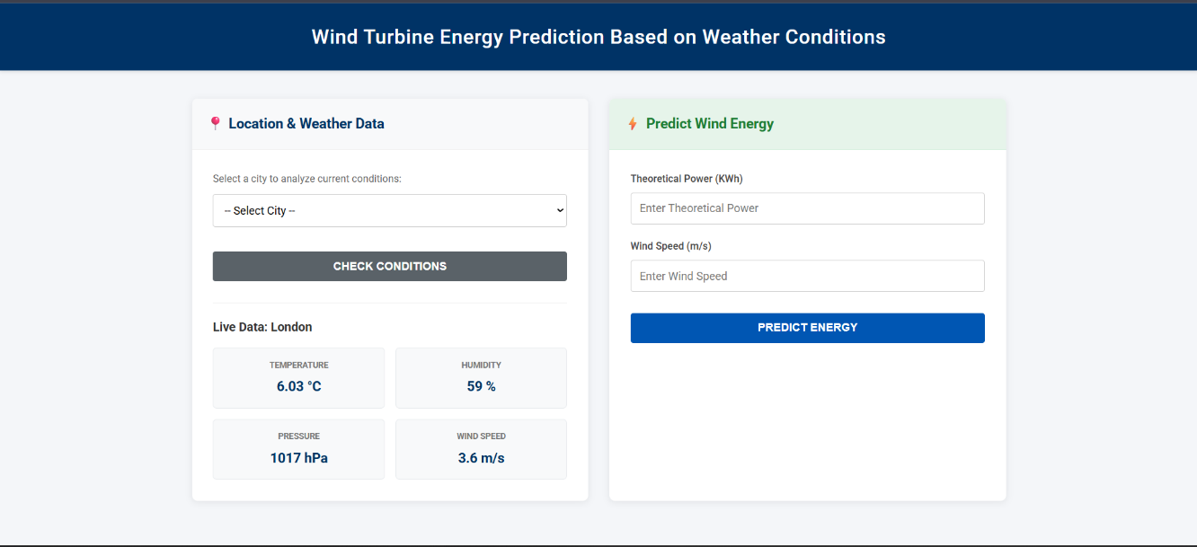

Testing Performed
🔹 1. Unit Testing
- Model prediction accuracy
- API response validation
- Input validation
🔹 2. Integration Testing
- Frontend ↔ Backend communication
- API data exchange
🔹 3. System Testing
- End-to-end workflow:
  - Signup → Login → Predict
🔹 4. Performance Testing
- API response time
- Model prediction speed
🔹 5. User Acceptance Testing (UAT)
- Verified correct prediction flow
- UI usability testing

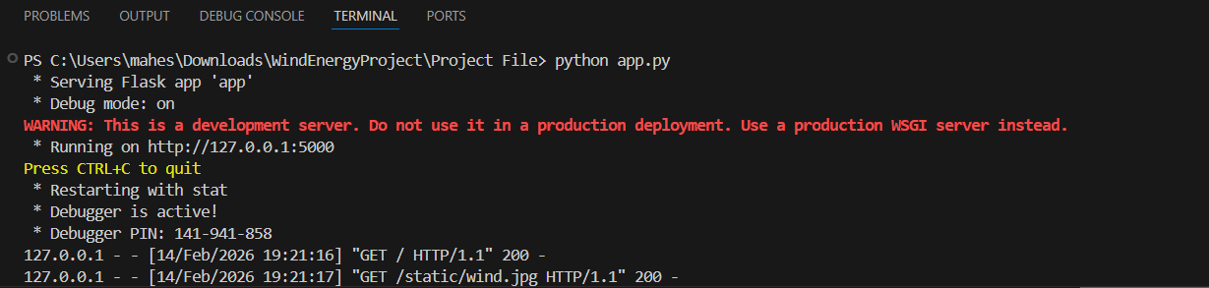

Screenshots or Demo
- Scatter plot of actual vs predicted power.
- Dashboard screenshot showing weather + prediction results.
- Line chart trends of wind speed vs power output.

🔟 Known AI Issues
- Data drift
- Extreme weather unpredictability
- Model bias
- Overfitting risk
- API latency
- Limited dataset size may affect generalization.
- API errors if invalid city names are entered.
- No authentication for dashboard access (future enhancement needed).

Workarounds (AI Perspective)
- Retrain model periodically
- Add fallback physics-based model
- Implement model monitoring
- Cache predictions

Future Enhancements (AI-Based)
- Transformer-based forecasting
- Federated learning across wind farms
- AutoML for tuning
- IoT sensor integration
- Predictive maintenance model
- Energy demand forecasting
- Deploy on cloud (AWS/GCP/Azure).
- Add JWT authentication for secure access.
- Expand dataset for improved accuracy.
- Add more visualizations (heatmaps, time-series forecasting).
- Integrate grid demand APIs for real-time energy balancing.

AI-Enhanced System Architecture
Weather Data API + Historical Data
↓
Data Cleaning & Feature Engineering
↓
ML Model (Random Forest / XGBoost / LSTM)
↓
Model Evaluation & Confidence Score
↓
Node.js API Layer
↓
MongoDB Storage
↓
React Dashboard Visualization
↓
Real-Time Alerts & AI Insights

Conclusion
- The Wind Turbine Energy Prediction project successfully demonstrates the application of machine learning and data-driven techniques to solve a real-world renewable energy challenge.

- By leveraging historical turbine data, preprocessing methods, and a Random Forest regression model, the project achieves strong predictive accuracy, enabling stakeholders to forecast energy output with confidence.

- The integration of a Flask-based dashboard and OpenWeather API ensures that predictions are not only technically sound but also accessible and user-friendly.

- Visualizations such as scatter plots, line charts, and correlation heatmaps further enhance interpretability, making the solution practical for energy companies, wind farm operators, and grid managers.
- Through structured Agile sprint planning, backlog management, and performance testing, the project was executed with clarity and measurable progress.

- Testing confirmed the robustness of the model, while defect analysis and bug tracking highlighted areas for improvement.

- Ultimately, this project provides a scalable foundation for future enhancements, including cloud deployment, advanced authentication, expanded datasets, and integration with grid demand APIs.

It stands as a strong example of combining data science, software engineering, and agile methodology to deliver a solution that addresses both technical and customer-centric needs in the renewable energy sector.

Final Summary
This system is:
- A Supervised Learning Regression System
- A Classification Alert System
- A Time-Series Forecasting Platform
- A Hybrid Physics + ML Model
- A Real-Time AI Dashboard
It transforms a normal web app into:
Intelligent Renewable Energy Forecasting & Monitoring Platform.

